Model Evaluation
The model with the lowest validation loss (providing the highest likelihood of the data) included depth_bin, season, diel, and salinity as features (model D in Table 1). Starting from a null model with a loss of 1.740 (geometric mean probability [gmp] of 17.6%), adding depth_bin (model A) reduced the loss to 1.457 (gmp 23.3%). Including season (model B) brought it to 1.368 (gmp 25.5%), and adding the diel features (model C) lowered it again to 1.352 (gmp 25.9%). With salinity included (model D), the final validation loss reached 1.340 (gmp 26.2%).
Depth occupancy, as observed by the tags and predicted by the model, skewed toward relatively shallow water. Nearly half (46.4%) of the observations were near the surface in the 0–25 m depth bin, and 85.6% were within 100 m of the surface (Table 2). The predictions paralleled this with predicted proportions of 45.6% and 85.5% respectively.
In both the observations and the predictions, Chinook salmon depth occupancy varied seasonally (Figure 1). The proportion of observations near the surface (0-25 m) was at a maximum in June, at ~68% (~66% in predictions). Fish occupancy then shifted deeper throughout the fall to only 30% of observations (26% predicted) being near the surface by November. Depth occupancy remained skewed toward deeper waters throughout the winter months (35–40% above 25m) before beginning to shift back toward the surface again in early spring.
Diel variation in depth occupancy also appeared, with notable seasonal shifts (Figure 2). During the summer, fall, and most of winter fish tended to be closer to the surface at night. August had the largest swing in observed depth occupancy with nearly three quarters (73%) of observations near the surface (0-25m) at night but only around a quarter (27%) near the surface during the day. This diel swing of 46% weakened throughout fall and winter (35% by October and 17% by January) and in February the pattern reversed with fish more likely to be near the surface during the day. While the model’s predictions captured these patterns, individual fish behavior was quite variable and large differences remained between the validation and training sets of observations, including a 25% discrepancy in May.
Finally, after controlling for depth, model predictions indicated that less saline (<31.3ppt) surface waters had higher occupancy than more saline surface (>31.3ppt) waters in all months except August and September (Figure 3). This pattern was strongest during the winter (30% difference in February) and weaker during the spring (6-14% difference). During the months of August and September the pattern flipped and occupancy near the surface was predicted to be higher in the more saline areas.
However, individual fish behavior was once again highly variable and the effect of salinity on model loss differed between the training and validation sets (Figure 4). From December to February, the two sets showed opposing trends. In December and January, the training data showed an improvement in loss (-0.03 and -0.05), while the validation data showed the opposite (+0.02 and +0.05). In February, the training loss remained unchanged, but the validation loss improved the most (-0.14) across any month. During the remaining months, changes in loss were smaller (up to 0.03), yet discrepancies in magnitude between the validation and training sets persisted even though the direction of the change was aligned.
Assessing Likelihood of Occupancy Near the Seafloor
Likelihood near the seafloor was assessed to understand the model’s implications for Chinook salmon occupancy in the portion of the water column occupied by trawl gear. Specifically, we were interested in where and when these likelihoods were minimized over space and time.
The minimum predicted likelihood of occupancy in the deepest bin varied across space and season (Figure 5). In February, the lowest likelihoods occurred along the shelf edge, where they dropped below 1%. Across the shelf, these values varied considerably, with neighboring cells often differing by 10% or more. In August, minimum likelihoods remained low (<1%) except for several persistent hotspots that were shared with February. One such hotspot, located just west of Kodiak, showed a minimum likelihood of 15%, roughly three times higher than the surrounding areas.
In a specific H3 cell near Chignik (Figure 6), both depth occupancy and diel variation changed meaningfully over the year. During winter, the deepest occupancy levels were observed, with ~50% of samples deeper than 25 m. At the same time, diel variability (the difference between maximum and minimum likelihood over the day) decreased during the winter, from nearly 20% in the 100 m depth bin in November to 10% in January. Beginning in March, occupancy shifted shallower, with only ~30% of predicted observations deeper than 25 m by May. Diel variation increased again in July and August reaching ~15% (in the 100m bin). As a result of this high daily variation in summer as compared to spring, highest occupancy near the surface (0-25m) occurred at night during the summer.
At a broader regional scale, the time of day that minimized likelihood of occupancy near the seafloor also varied across space and season (Figure 7). In August, this minimum occurred at night in nearly all locations, with only one exception. In contrast, February showed much more spatial variation. Along the shelf edge, like in August, nighttime was when the likelihood of occupancy near the seafloor was minimized. However, on the shelf, that minimum could occur at dusk, dawn, or even during the day indicating that diel variation during February depends on location.

Model | Features | Loss Train | Loss Validation | Geometric Mean Probability  Validation
Null |  | 1.835 | 1.740 | 17.6%
A | depth_bin | 1.412 | 1.457 | 23.3%
B | A + season | 1.330 | 1.368 | 25.5%
C | B + diel | 1.313 | 1.352 | 25.9%
D | C + salinity | 1.308 | 1.340 | 26.2%
Table 1: Model Improvements over Features. Deep learning was used to train on and then predict the depth bins occupied by individual Chinook salmon at 15 minute intervals in the Gulf of Alaska and Eastern Bering Sea. The objective of the training was to optimize the overall likelihood of the data given the predictions by minimizing a categorical cross entropy loss function. Beginning with a null model - predicting equal probabilities across all depth bins – each new model (A – D) demonstrates the improvement in loss each new feature brings to our selected model D. Training loss represents the loss over the data the model saw during training, validation loss is the loss over a holdout set. Geometric mean probability is the geometric mean of the probability of the data given the model.

Depth Bin | Proportion of Samples | Predicted Proportion of Samples
[0, 25] | 46.4% | 45.6%
(25, 50] | 16.6% | 16.4%
(50, 75] | 13.0% | 12.6%
(75, 100] | 9.6% | 10.8%
(100, 150] | 10.1% | 9.8%
(150, 200] | 3.1% | 3.8%
(200, 250] | 0.6% | 0.8%
(250, 300] | 0.3% | 0.2%
(300, 400] | 0.1% | <0.1%
(400, 500] | <0.1% | <0.1%
Table 2: Depth Skew. Over 15 minute interval observations of depth occupancy across tagged Chinook salmon in the Gulf of Alaska and Eastern Bering Sea, the proportion of samples in each of our depth bins (units in meters) as well as the proportions predicted by a deep learning model.

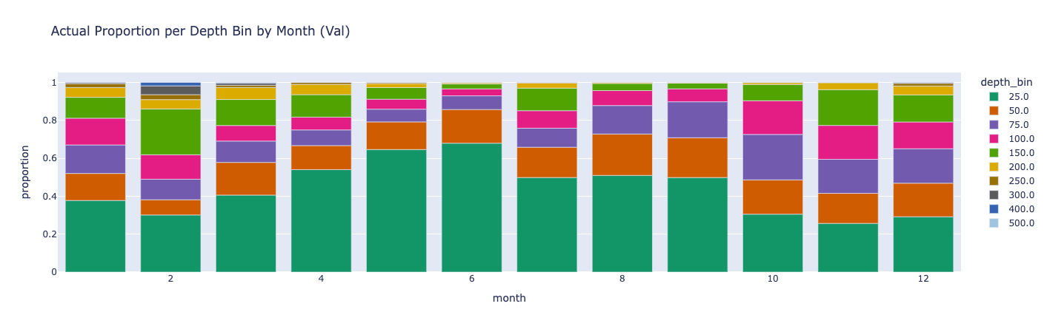
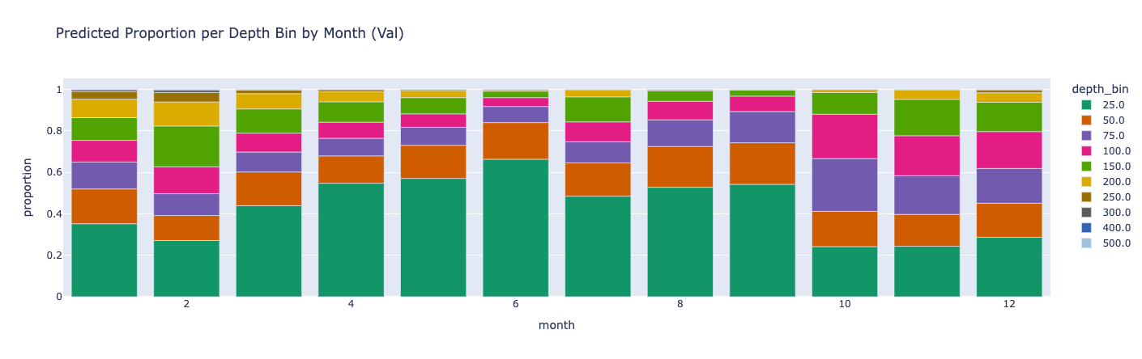
Figure 1: Seasonal Shifts in Depth Occupancy. (Top) Using observations of depth at 15-minute intervals from individual Chinook salmon (GOA and EBS), the proportions of samples in each depth bin across all months. (Bottom) For those same samples, mean predicted probability of the occupied depth from a deep learning model binned across all months.
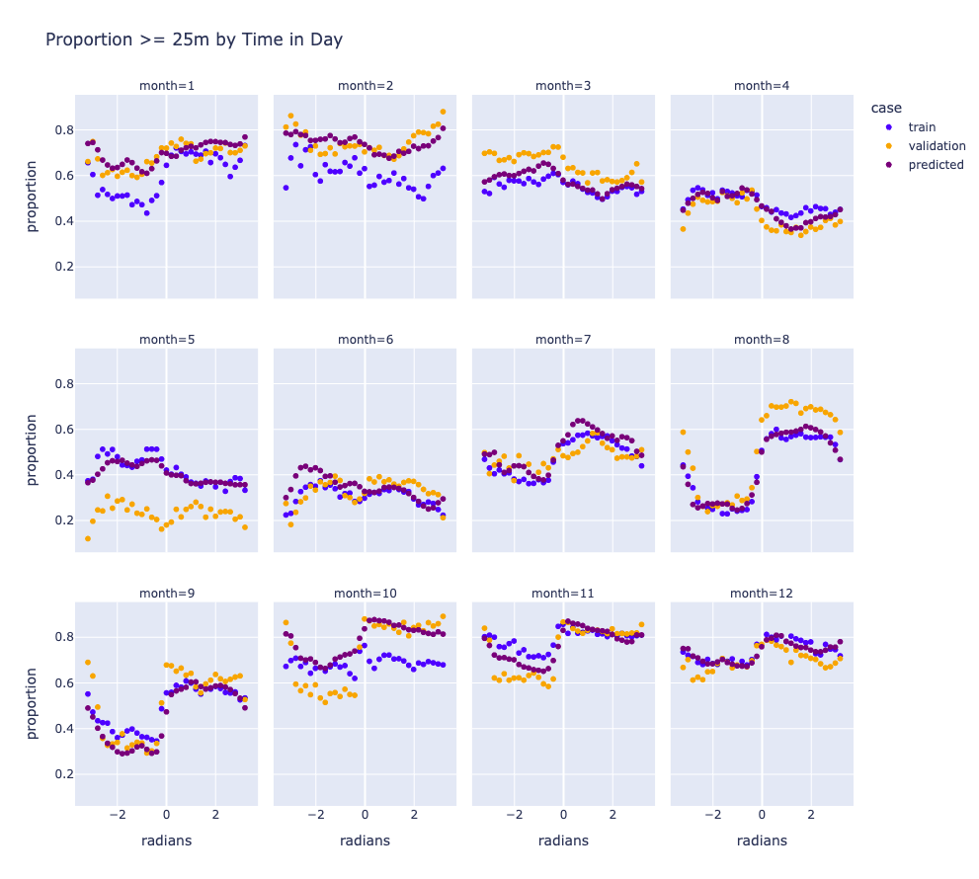
Figure 2: Diel Variation Using observations taken at 15-minute intervals from Chinook salmon in the GOA and EBS, the proportions of samples deeper than 25m as a function of time of day across all months. Validation is the proportion over the validation data, train is the proportion over the training data, and predicted is the mean predicted probability of the occupied depth over the validation data.
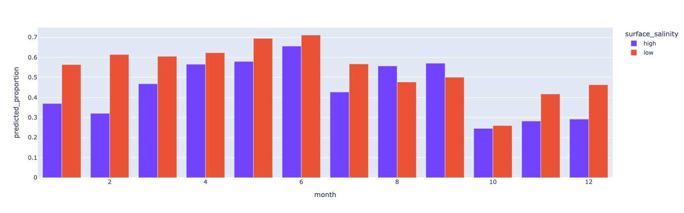
Figure 3: Effect of Salinity Using predictions of depth occupancy at 15-minute intervals for Chinook salmon using a deep learning model, predicted proportions of fish within 25m of the surface when surface salinity is above (high) and below (low) 31.3ppt. Predictions were made over the validation dataset.
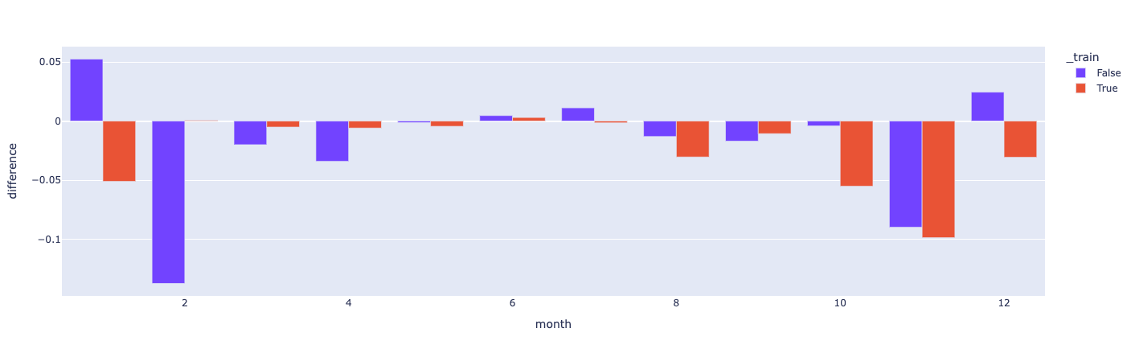
Figure 4: Variation in Performance of Salinity as a Feature Change in loss across months when adding salinity as a feature to a deep learning model of Chinook salmon depth occupancy. Red indicates the training dataset whereas blue indicates the validation dataset.

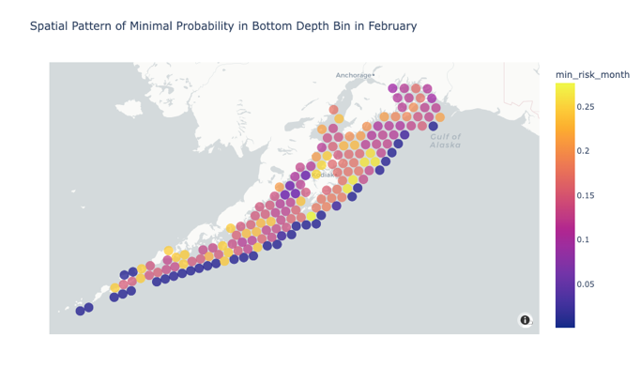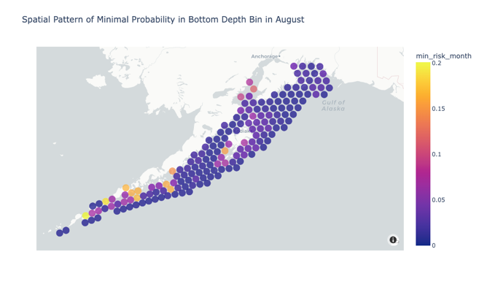
Figure 5: Spatial Distribution of Minimum Likelihood. Minimum likelihood of Chinook salmon occupancy in the deepest bin over each hour in the months of February (left) and August (right) as predicted by our deep learning model. 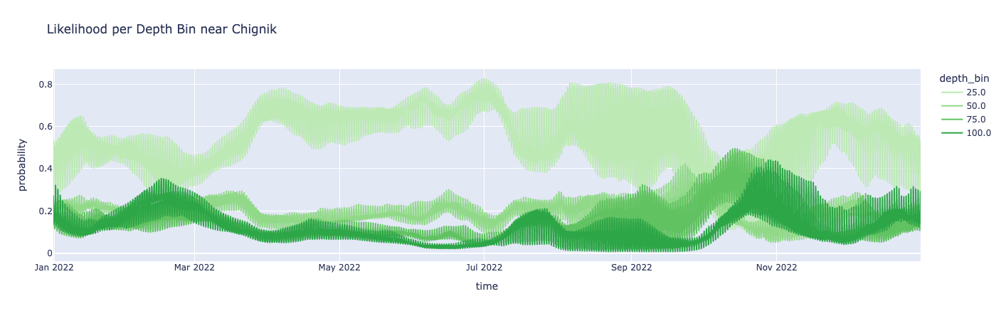
Figure 6: Full Year of Likelihoods Predicted likelihood, using our selected model, of occupancy per depth bin for Chinook salmon across all hours in 2022 for an H3 cell near Chignik, AK.
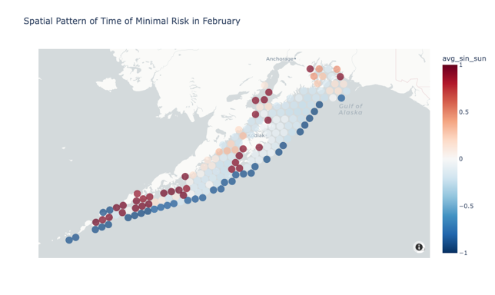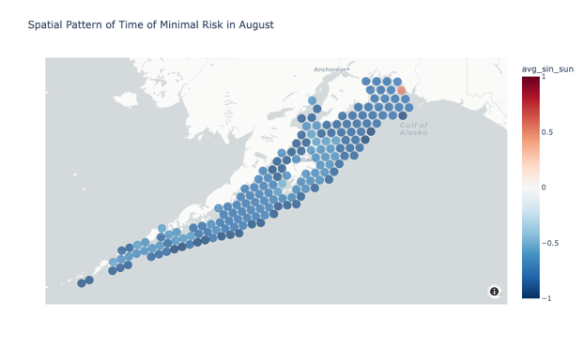
Figure 7: Time of Day Minimization. Time of day when the predicted likelihood, from our selected model, in the deepest bin for Chinook salmon is minimized on February (left) and August (right) 15. Negative values indicate nighttime whereas positive values indicate daytime.

